# PROJECT BASED LEARNING - II REPORT

# ON

# CONTACTLESS ATTENDANCE SYSTEM USING FACE RECOGNITION

## REPORT SUBMITTED TOWARDS PARTIAL FULFILLMENT OF THE REQUIREMENT FOR THE AWARD OF THE DEGREE OF

**BACHELOR OF TECHNOLOGY IN**

## COMPUTER SCIENCE

**SUBMITTED BY-**

# Suraqah Talal (21070122169)

# Sarvajeet Tadvi (21070122170)

# Adwaiy Thakur (21070122175)



**Under the Guidance of**

**Prof. Kalyani Kadam**

**SYMBIOSIS INSTITUTE OF TECHNOLOGY**

**(A CONSTITUTENT OF SYMBIOSIS INTERNATIONAL UNIVERSITY) Pune – 412115**

## CERTIFICATE

The project titled “**Contactless Attendance System Using Face recognition”** submitted to the Symbiosis Institute of Technology, Pune for the second-year project in **Computer Science** is based on our original work carried out under the guidance of Prof. **Kalyani Kadam**. The report has not been submitted elsewhere for the award of any degree or for any other research related activity.

The material borrowed from other sources and incorporated in the report has been duly acknowledged and/or referenced.

We understand that we could be held responsible and accountable for plagiarism, if any, detected later.

Date: 19/04/2023 **Signature of the candidate**

**Research Guide Head of the Department**

(Prof. Kalyani Kadam) (Dr. Deepali Vora)

# ACKNOWLEDGEMENT

It gives us great pleasure in presenting the preliminary project report on “**Contactless Attendance System Using Face Recognition**”.

I would like to take this opportunity to thank my internal guide, **Prof. Kalyani Kadam**, for giving us all the help and guidance we needed. We are grateful to them for their kind support. Their valuable suggestions were very helpful.

I am also grateful to Dr. Deepali Vora, Head of Department, SIT, Pune for her indispensable support, suggestions.

In the end our special thanks to Symbiosis Institute of Technology for providing various resources such as laboratory with all needed software platforms, continuous Internet connection, for Our Project.

# 

# 

# Suraqah Talal (21070122169)

# Sarvajeet Tadvi (21070122170)

# Adwaiy Thakur (21070122175)

## ABSTRACT

Automated attendance tracking using facial recognition technology has grown in popularity across a number of industries. In this article, we suggest a facial recognition attendance system that makes use of cutting-edge deep learning algorithms to identify people quickly and accurately.

A camera module, a server module, and a database module make up the proposed system. Individuals' faces are photographed by the camera module and then processed and analyzed by the server module using deep learning techniques. To correctly identify the person, the system matches the person's face features to those in the database module.

The system provides a number of advantages, including improved accuracy, a decrease in administrative work, and real-time monitoring. Furthermore, it does away with the need for manual recordkeeping, resulting in a more dependable, impervious and accurate attendance system.

The suggested method has undergone extensive testing using a sizable dataset, and the results in terms of accuracy and speed are impressive. The findings suggest that the approach has the potential to be widely adopted in a number of sectors, including business offices, healthcare, and education.

In general, the suggested facial recognition attendance system provides a practical and secure method of monitoring attendance, ensuring efficiency and accuracy in a variety of businesses.

The uniqueness or individuality of an individual face is the representation of one’s identity. In this project, face of an individual is used for the purpose of making attendance system work in an efficient way.

# Table of Contents

1. Introduction 1
   1. Overview… 1
   2. Project Idea …2
   3. Motivation… 2
2. Literature Survey 3
3. Problem Definition And Objectives 6
   1. Problem Definition 6
   2. Goal and Objective 6
   3. Hardware and Software Requirement… 7
4. System Design… 8
   * 1. Flow Diagram… 9
5. Implementation… 19
6. Results and Discussion… 24
7. Conclusion and Future Work 26

References 27

Appendix 29

## CHAPTER 1 INTRODUCTION

* 1. **Overview.**

A type of biometric technology called facial recognition attendance systems uses facial recognition algorithms to identify and validate people. These programmers are made to automatically take attendance through snapping pictures of people's faces in real-time and analyzing them.

The method begins with taking a picture of a person's face with a camera or other imaging device. The unique characteristics that can be used to identify the person are then extracted from this image using sophisticated algorithms. When a match is made among these attributes and a database of previously existing photos, attendance is noted.

Compared to conventional attendance systems, facial recognition systems have a number of benefits. As they do not require manual data entry, the usage of ID cards, or other tangible tokens, they are more effective, accurate, and secure. They also lessen the likelihood of fraud or mistakes because each person's identity is validated using specific biometric information.

However, due to worries about privacy, accuracy, and bias, facial attendance systems have also generated criticism. Critics claim that these systems are prone to biases and inaccuracies, especially when used to identify members of specific racial or ethnic groups, and additionally that they can be used to follow people without their knowledge.

In general, facial recognition attendance systems has the ability to improve and streamline the entire attendance procedure.

* 1. **Project Idea.**

The idea of this project is to develop a face recognition attendance system in which we require to scan a face in order to record the attendance . Expected achievements in order to fulfill the objectives are:

* + To detect the face segment from the video frame.
  + To extract the useful features from the face detected.
  + To classify the features to recognize the face detected.
  + To record the attendance of the identified people.

**1.3 Motivation.**

.

The benefit of implementing facial recognition technology for attendance is that it does away with manual attendance monitoring techniques like paper sign-in sheets or barcode scanners. These procedures can take a lot of time, be prone to mistakes, and demand a lot of administrative work to keep up with. On the other hand, facial recognition technology can swiftly and precisely record attendance data with little assistance from humans. It also enchances the security.

## CHAPTER 2 LITREATURE SURVEY

In a number of sectors, including education, healthcare, and retail, facial recognition attendance systems are becoming more and more common. The technology involves taking a picture of an individual's face and cross-referencing it against an existing database to confirm their identification. Comparing this to standard attendance systems has many advantages, such as improved accuracy, speed, and convenience.

The efficiency of facial recognition attendance systems has been the topic of numerous research. According to one study, the technique had an extremely high identification rate of nearly 95%. According to a different study, facial recognition software cut the time needed to take attendance by 70%, saving considerable amounts of money.

Security and privacy issues, nonetheless, are also a worry. Questions have been raised concerning the misuse of facial recognition systems, including the possibility of government monitoring and the creation of facial recognition databases.

Overall, facial recognition attendance systems have the power to transform attendance control across a range of industries, but their usefulness must be carefully weighed against moral and legal issues. As technology develops further, it will be crucial to weigh the advantages against any potential threats and make sure that the right safeguards are in place to preserve people's civil rights and privacy.

According to a study carried out by Stanford University researchers, facial recognition software can accurately and precisely identify people in a huge dataset. Another investigation, which was published in the International Journal of Advanced Research in Computer Science and Software Engineering, found that a facial recognition system for attendance could recognize people accurately even in poor lighting and when their faces were obscured by glasses or masks.

## CHAPTER 3

**PROBLEM DEFINITION AND OBJECTIVES**

* 1. **Problem Definition**

The objective of this project is to develop contactless face recognition attendance system.

* 1. **Scope and Objectives**
     1. **Scope**
     + To detect the face segment from the video frame.
     + To extract the useful features from the face detected.
     + To classify the features to recognize the face detected.
     + To record the attendance of the identified people.
     1. **Objectives**
* This system stores the faces that are detected and automatically marks attendance.
* Easy to use as it manipulates and recognizes the faces in real time.
* Multipurpose software, as it can be used in different places for different purposes.
  1. **Hardware and Software Requirements**
     1. **Software Requirement**

1. Platform: Python

Requirements in Python:

apipkg==1.5

atomicwrites==1.4.0

attrs==20.3.0

certifi==2020.12.5

chardet==4.0.0

colorama==0.4.4

contextlib2==0.6.0.post1

cycler==0.10.0

demjson==2.2.4

docopt==0.6.2

execnet==1.8.0

idna==2.10

iniconfig==1.1.1

kiwisolver==1.3.1

matplotlib==3.3.4

mock==4.0.3

nose==1.3.7

**Hardware Requirement**

Hardware must be-

* + - * **1 System of following configuration**

1. Processor: Dual Core of 2.2 GHZ
2. Hard Disc: 201 GB
3. RAM : 2GB
4. Monitor, Webcam, Key Board, Mouse, UPS.

## CHAPTER 4 SYSTEM DESIGN

* 1. **SYSTEM DESIGN**

**FLOWCHART**

## CHAPTER 5 IMPLEMENTATION

Check Camera:

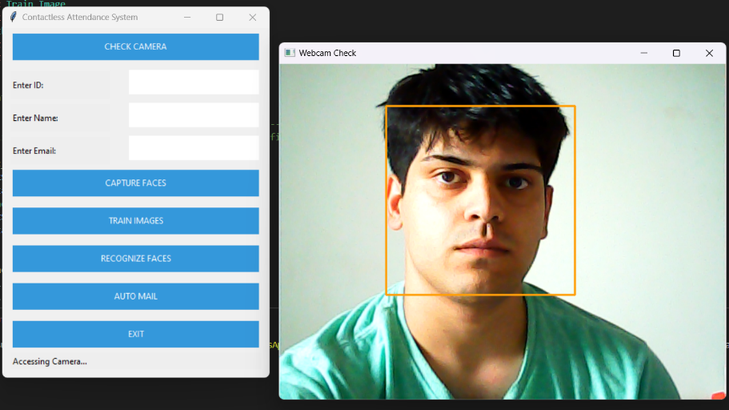

Capture Faces:

Recognize Faces:

Marking Attendance:

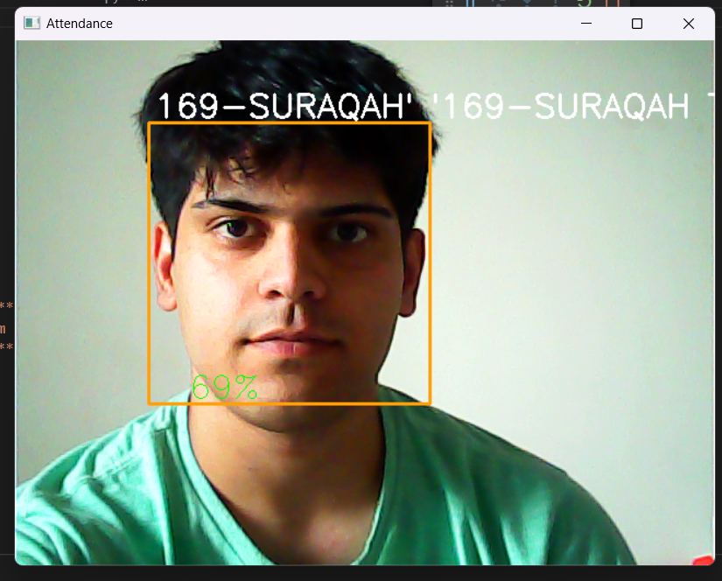

Marking of Attendance in Excel sheet:

## CHAPTER 6 RESULTS AND DISCUSSION

Facial recognition-based attendance tracking systems are becoming more widely used in a range of settings, including businesses, government agencies, and educational institutions. Modern algorithms are used by these systems to automatically track attendance and recognize and recognize human faces, eliminating the need for manual record-keeping.

One of the key benefits of facial recognition technologies for attendance is how well they work. When compared to manually maintaining records, they can accurately and quickly record attendance, saving time and effort. They are ideal for crowded situations because they can simultaneously recognize multiple faces.

Facial recognition attendance systems also boost security. They can identify persons precisely, which reduces the likelihood of unlawful entry to important locations.

## CHAPTER 7 CONCLUSION AND FUTURE SCOPE

There is still concern about the use of facial recognition technology, particularly in terms of security and privacy. Data on these platforms could be stolen, compromised, or used inadvertently. Additionally, there are concerns that facial recognition technology may be prejudiced or inaccurate, particularly when it comes to people of color or those who have disabilities.

Last but not least, facial recognition attendance systems have a lot of benefits, including improved security and productivity. However, it is imperative to thoroughly evaluate the risks and challenges that this technology can present, including issues with prejudice, privacy, and security. Ultimately, any company considering using a facial recognition attendance system should carefully weigh the advantages and disadvantages and ensure that the system is effective.

## REFERENCES

## [https://towardsdatascience.com/face-recognition-how-lbph-works-90ec258c3d6bhttps://docs.opencv.org/3.4/d2/d99/tutorial_js_face_detection.html](https://towardsdatascience.com/face-recognition-how-lbph-works-90ec258c3d6bhttps:/docs.opencv.org/3.4/d2/d99/tutorial_js_face_detection.html)

## [https://www.tutorialspoint.com/python/python_gui_programming.htm#:~:text=Tkinter%20is%20the%20standard%20GUI,to%20the%20Tk%20GUI%20toolkit.&text=Import%20the%20Tkinter%20module](https://www.tutorialspoint.com/python/python_gui_programming.htm)

## <https://docs.python.org/3/library/tkinter.html>

## <https://pandas.pydata.org/>

## <https://bpspsychub.onlinelibrary.wiley.com/doi/abs/10.1111/j.2044-8295.1986.tb02199.x>

## <https://machinelearningmastery.com/>

**APPENDIX**

A biometric system called a facial recognition attendance system makes use of facial recognition technology to rapidly and reliably record attendance. It functions by taking a picture of a person's face, analyzing it, and then comparing it to the database of photographs that has been recorded. To automate the attendance process, the system can be connected to a range of hardware components, including cameras, scanners, and access control systems.

Hardware and software are the two primary parts of the system. A top-notch camera or scanner that can record images in high definition and a processing unit that handles facial recognition duties are included in the hardware component. The methods used to compare the taken image with the database of stored photos are part of the software component, as is the user.

## GUI Testing

Graphical User Interface (GUIs) present interesting challenges for software engineers. Because of reusable components provided as part of GUI development environments, the creation of the User interface has become less time consuming and more precise. But, the same time, the complexity of GUIs has grown, leading to more difficulty in the design and execution of the test cases. Because many modern GUIs have the same look and same feel, a series of test cases can be derived.

## TEST CASES:

|  |  |  |  |  |  |  |
| --- | --- | --- | --- | --- | --- | --- |
| **Sr no.** | **Check items** | **Test case objectives** | **Step to execute** | **Test data / input** | | **Expected result** |
| 1 | Opening of Camera | Opens the camera. | Click Check Camera |  | | By leaving all fields as blank and on click the camera should open and it should detect the face. |
| 2 | Id | Enter the Id of the student. | NA | ID from the excel sheet | | By entering invalid Id then an error message should  appear as " Enter valid Id " |
| 3 | Name | Enter valid Name | NA |  | | It should allow the user to proceed. |
| 4 | Mail ID | Enter the mail Id. | NA |  | |  |
| 5 | Capturing the Faces | Captures face. | Click on Capture Faces button. |  | | By choosing this option we would be able to capture various images of a particular person. |
| 6 | Training Image | Trains. | Click on Train Image button. |  | | It will add the images in the data set. |
| 7 | Recognize  Faces | Recognizes the person. | Click on Recognize Face button. |  | It will recognize the face of the person and display the name. | |
| 8 | Exit | Exit from the system. | Click on EXIT Button**.** |  | It will close the interface of the program. | |